# CS 255 System Design Document Template

This template lays out all the different sections that you need to complete for Project Two. Each section has guidance to prompt your thinking. You will need to continually reference the interview transcript as you work to make sure that you are addressing your client’s needs. There is no required length for the final document. Instead the goal is to complete each section based on what your client’s needs are. Remove this note when you are finished, and replace all bracketed text with the relevant information.

## UML Diagrams

### UML Use Case Diagram

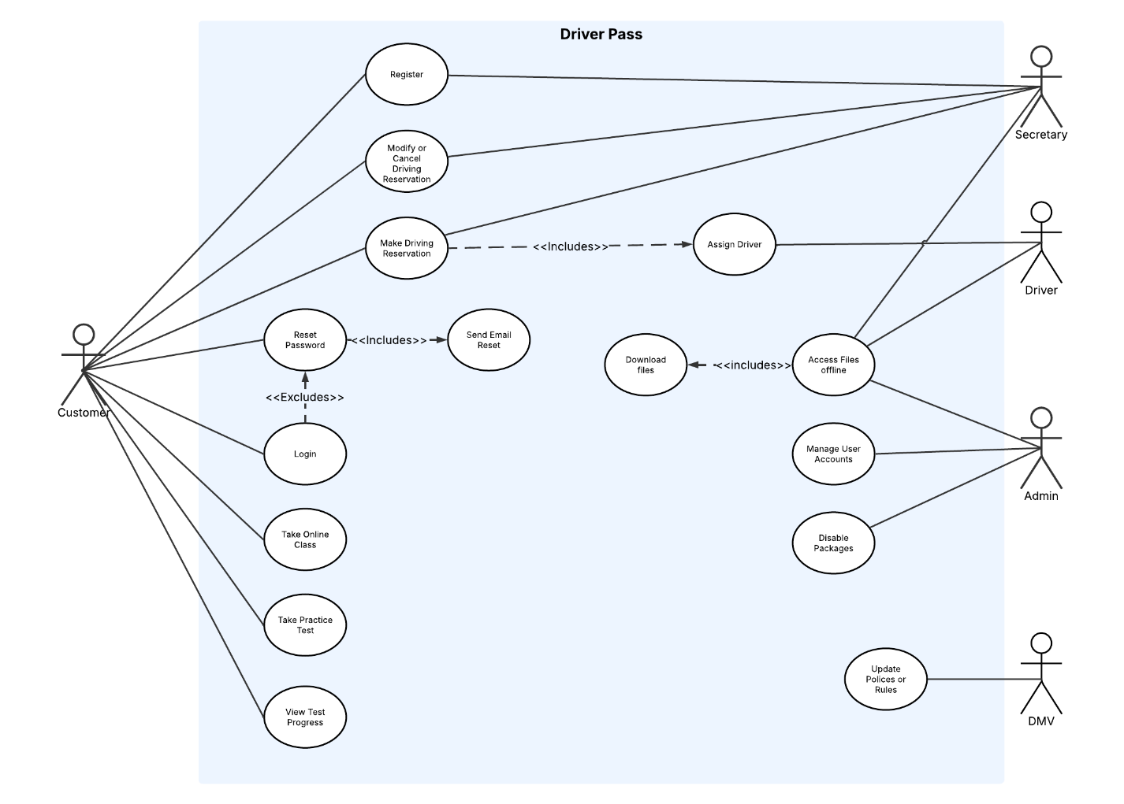

### UML Activity Diagrams

### UML Sequence Diagram

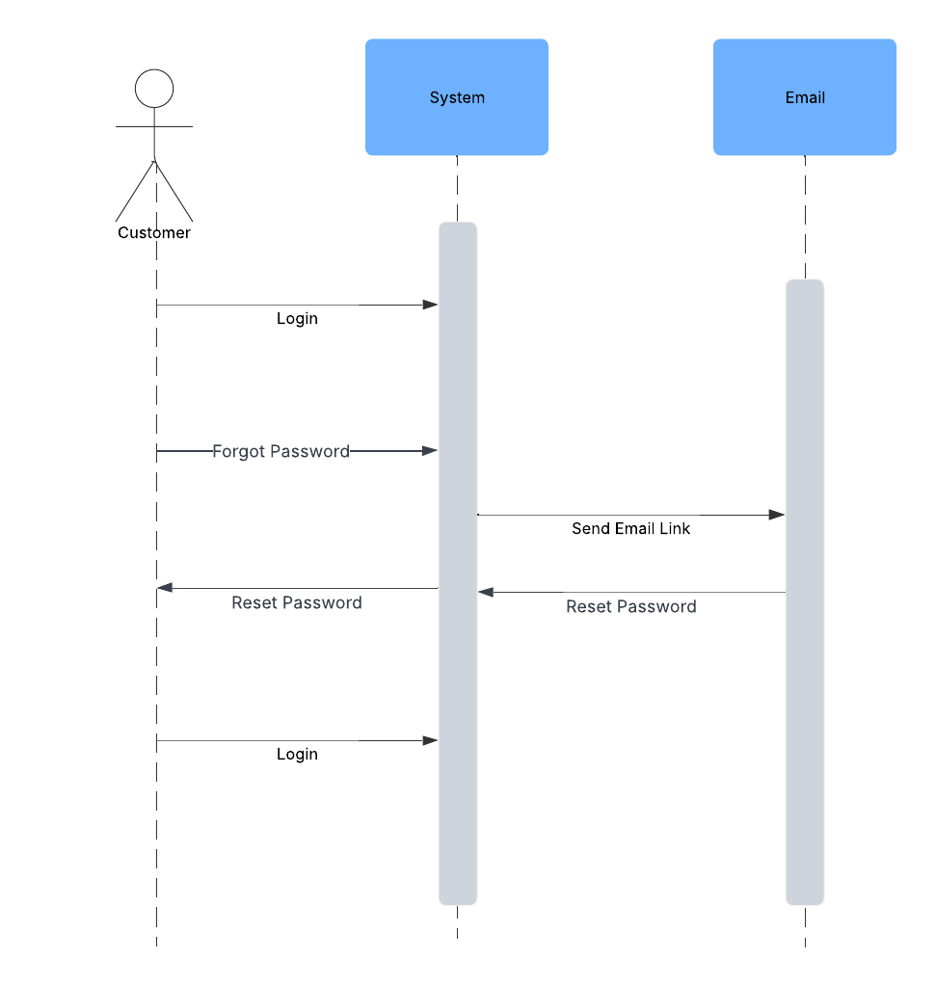

### UML Class Diagram

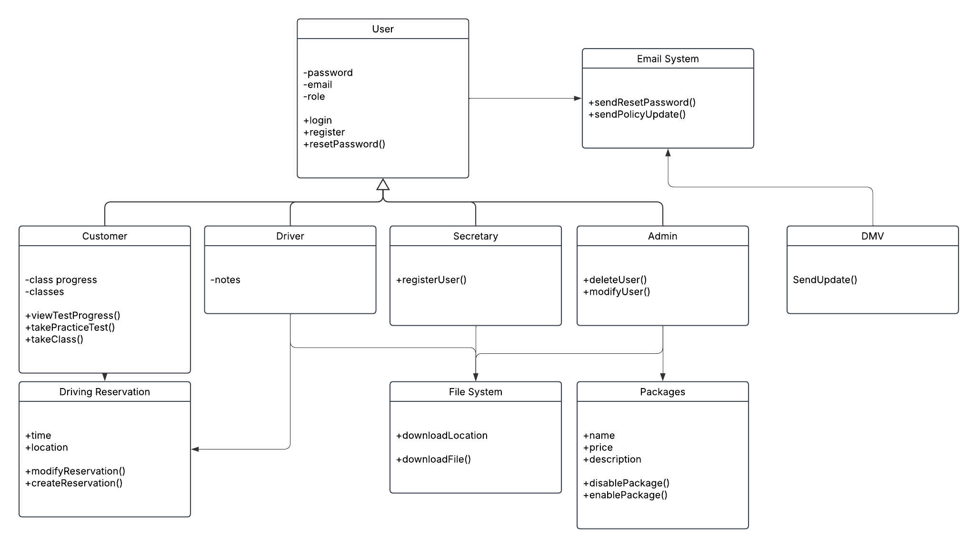

## Technical Requirements

*These are the essentials that will support everything from customer bookings to staff management and online learning.*

* ***Hosting and Servers***
  + *The system will be hosted in the cloud (like AWS, Azure, or a similar provider), which allows it to be available anytime and able to grow as more people use it.*
  + *The hosting service should include backups and security features to protect user data and prevent system crashes.*
* ***Database System***
  + *A reliable database is needed to store important information such as user accounts, lessons, payments, and progress.*
  + *The data should be protected using secure methods to make sure no unauthorized access happens.*
* ***User Interface (Frontend)***
  + *The platform will be accessed through a web browser on both computers and mobile devices.*
  + *It should be built using modern web technologies so it works well and looks good on different screen sizes.*
* ***System Logic (Backend)***
  + *The system needs a backend service that handles things like logging in, saving reservations, sending emails, and getting updates from the DMV.*
  + *It will also make sure that users only see and do things that match their roles (like customer vs. admin).*
* ***Security Features***
  + *All data sent between users and the system must be encrypted to keep it safe.*
  + *The system will have protections in place to block repeated hacking attempts and notify an admin if anything suspicious happens.*
* ***Development Tools***
  + *The development team will use tools like code editors, version control (to manage changes), and bug trackers to keep the project organized.*
  + *Testing tools will also be used to make sure everything works before going live.*
* ***Reporting and Exporting***
  + *The system should be able to generate downloadable reports (such as Excel or CSV files) for admins and staff to view lesson schedules and customer progress.*
* ***Hardware (Basic Needs)***
  + *The system should be able to run on any modern web server.*
  + *Staff and customers just need a device with internet access and a modern web browser like Chrome, Firefox, Safari, or Edge.*